User manual

- In wooden electronics box, plug cable A into battery A.
- In wooden electronics box, plug cable B into battery B.
- Place blanket on left shoulder.
- Hold baby doll, and cover with flap. Line up circle with back of baby and pat.
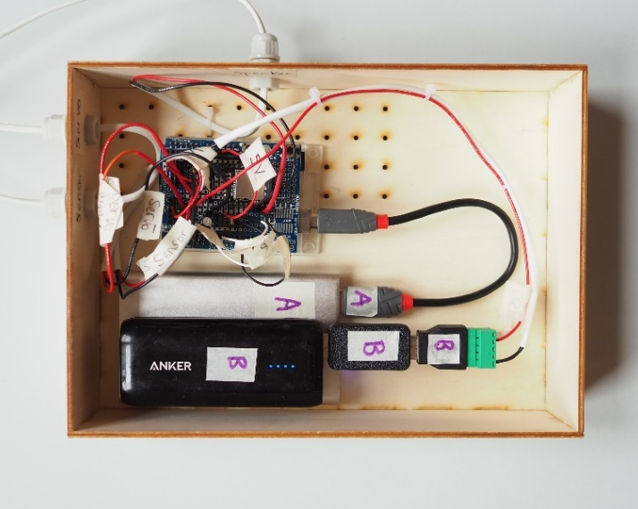
- Batteries are held down with blue tac and can be removed from the box for charging.

Image right >
This is what the
electronics box should look
like when correctly plugged in.

Image below left:
This is what blanket should
Look like on shoulder when
It is the right way around.

Image below right:


Blanket is upside down.




Images show how to wrap the baby doll and
The circle that needs to be lined up with the
dolls back. This is where to pat.

Problem solving
If nothing happens look for these issues.
- In wooden electronics box. Is cable A plugged into battery A? Cable B plugged into battery B?
- Are both batteries on, lighting up and charged? Lights circled below show charged battery packs.
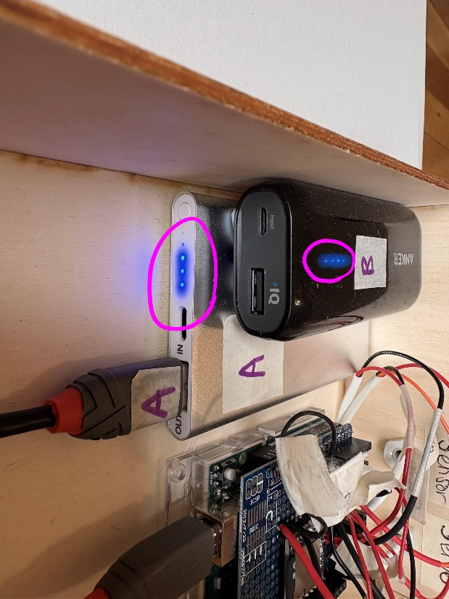

- Is the Arduino on? Can you see a green light?

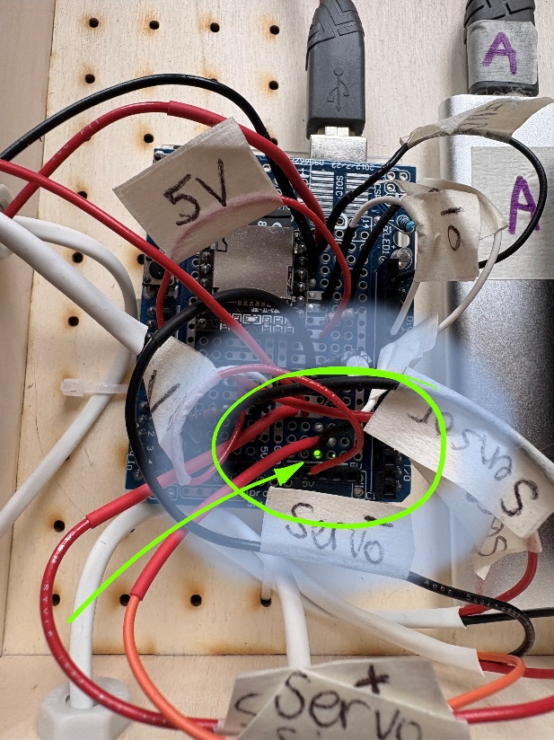

- Are any wires disconnected? Either in the blanket or in the wooden box? Image below left shows two disconnected wires in the blanket. Image on right is correctly connected wire in blanket.

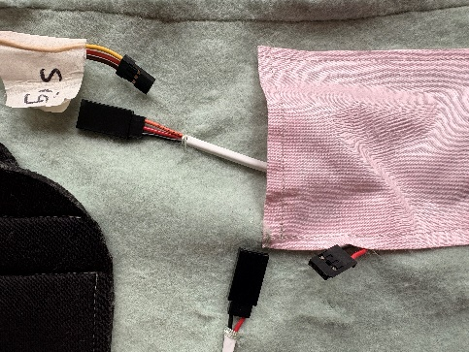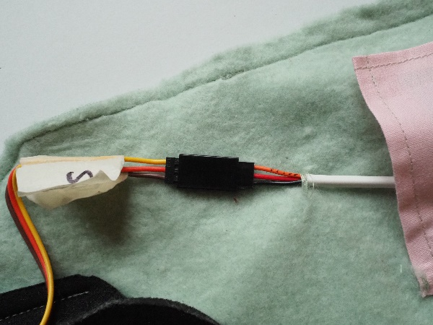

- Is the servo / Patting motor plugged in the right way around?

